1. **HOW TO CREATE AN EC2 INSTANCE**
2. Login to AWS Home page >> Search for EC2 >> Click on **EC2** under **services** section >> You will see a page like below
3. Under **Instances** on the **left** pane>> **Click** on **Instances(in normal text).** 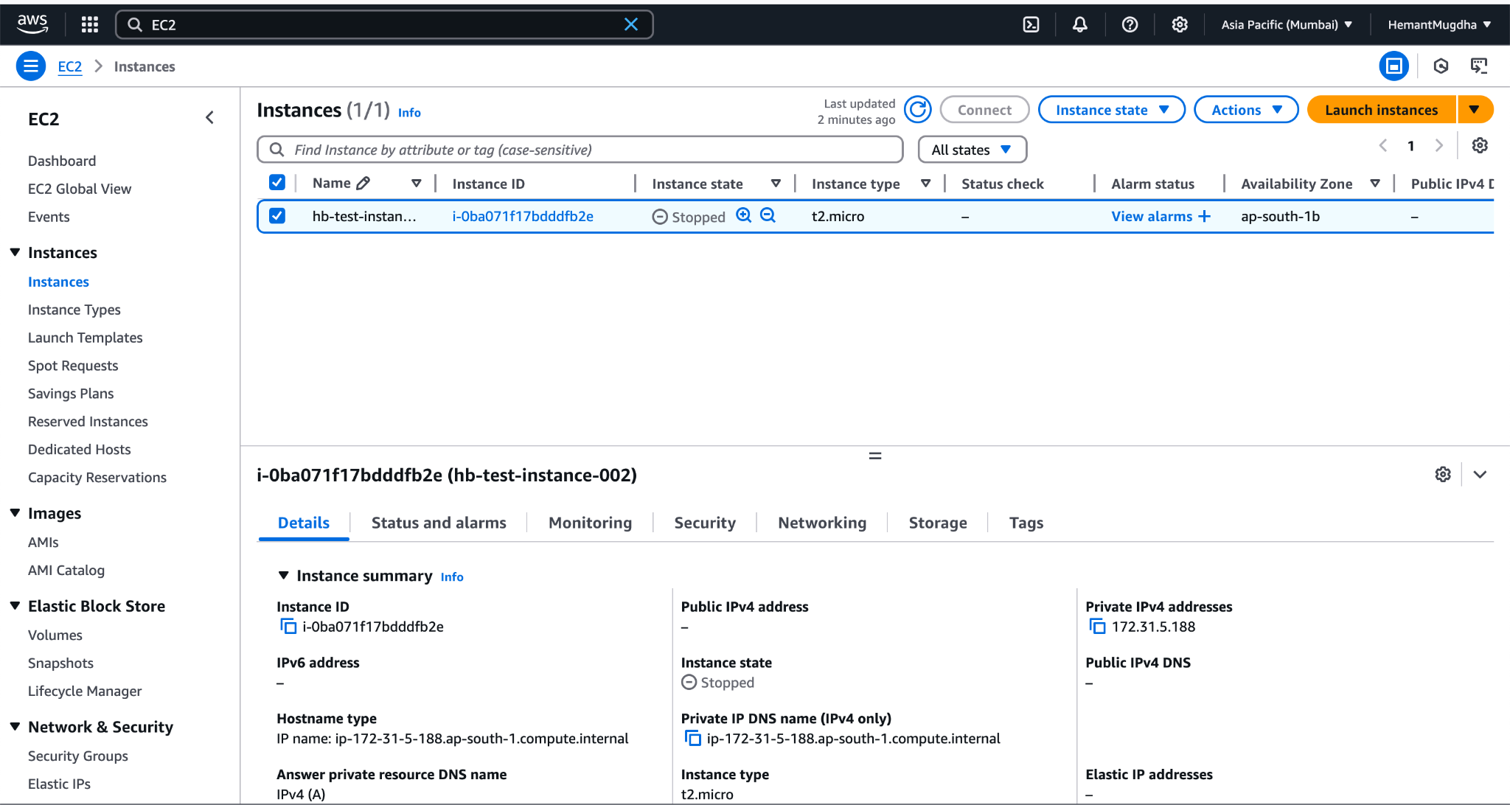
4. Under **Instances** on the **left** pane>> **Click** on **Instances(in normal text).**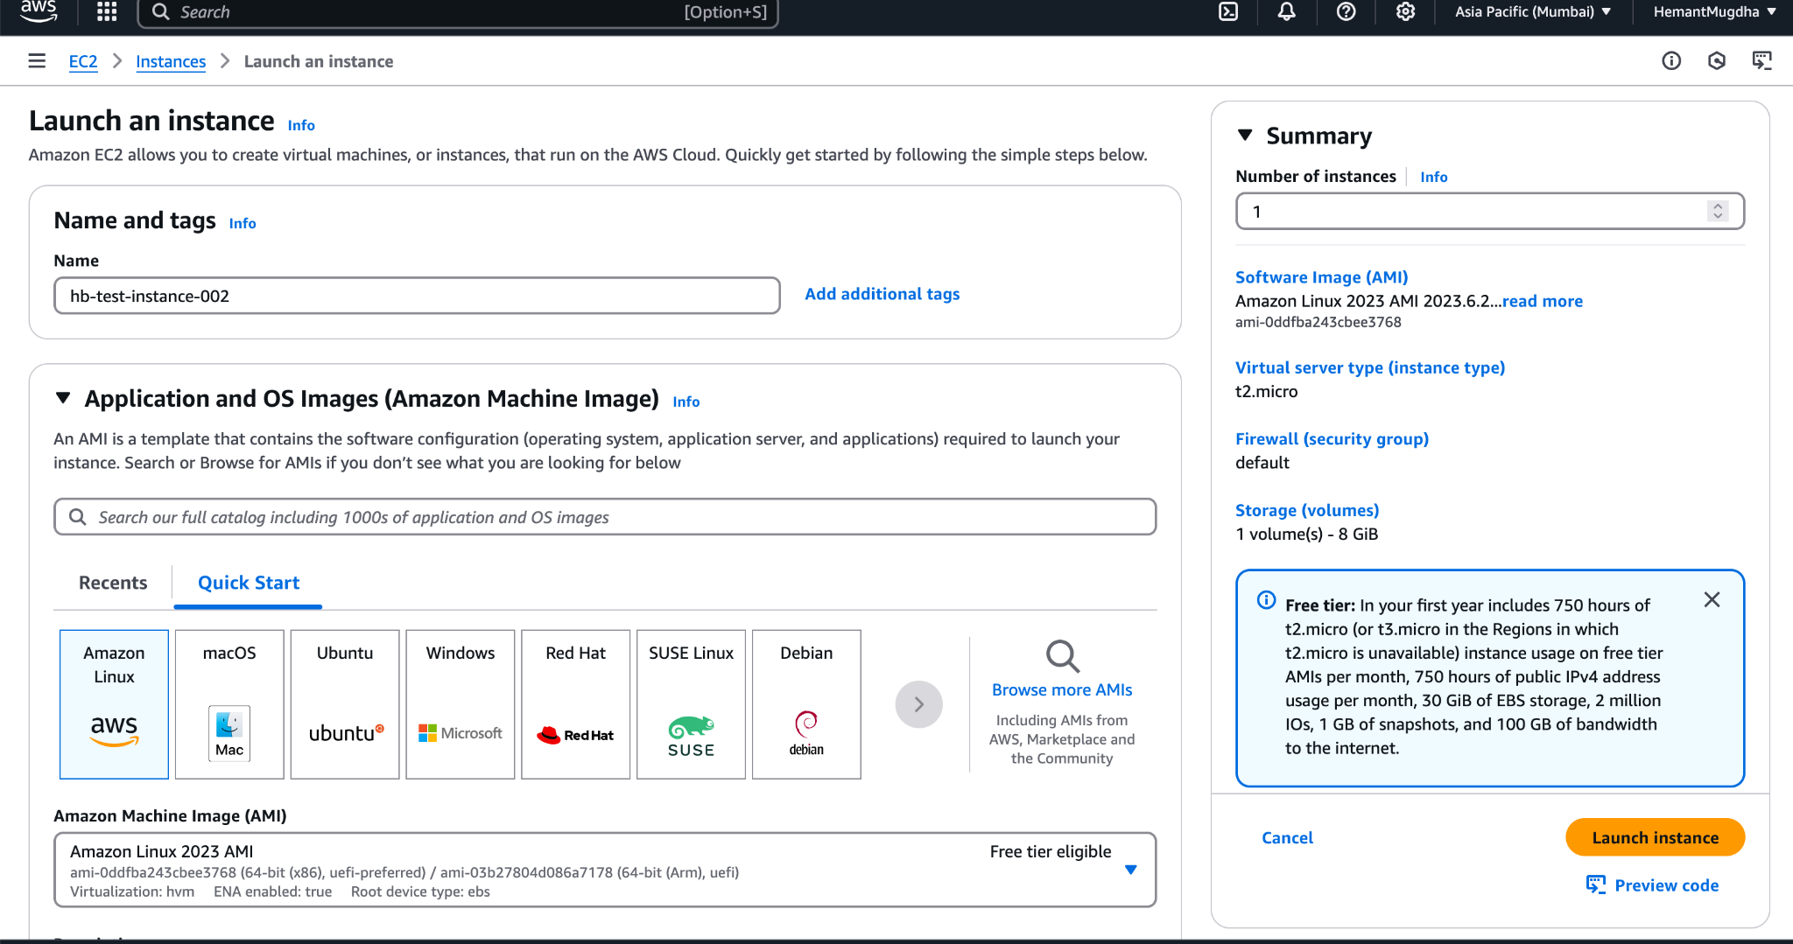
5. Click on **Launch Instances** button(Yellowish Orange one on the left)
6. **Launch an Instance** wizard opens.
7. Provide name for the new instance.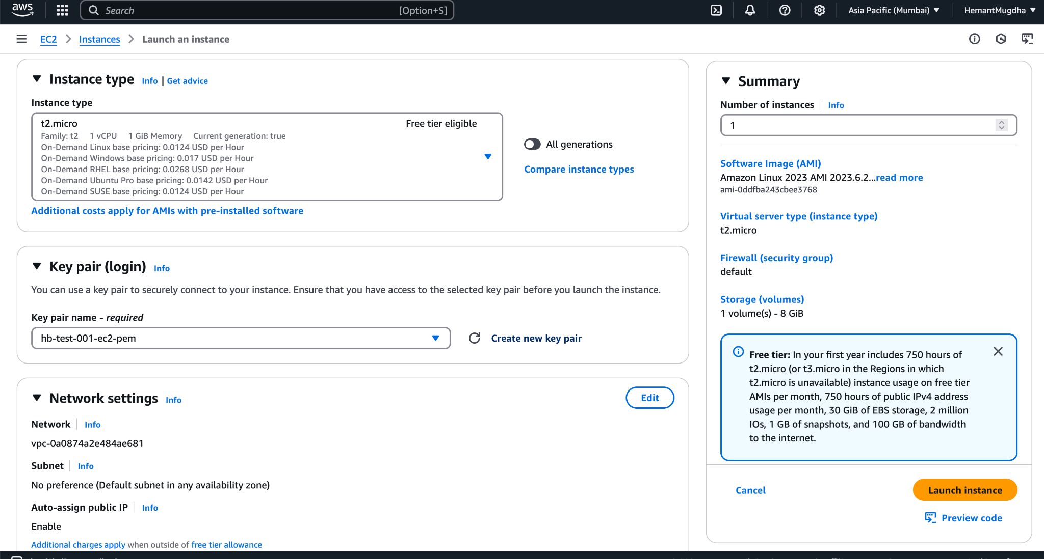
8. Select an existing key pair(as done in previous exercise)
9. Select Security group. Select **Default Security Group** >> Click on **Launch Instance**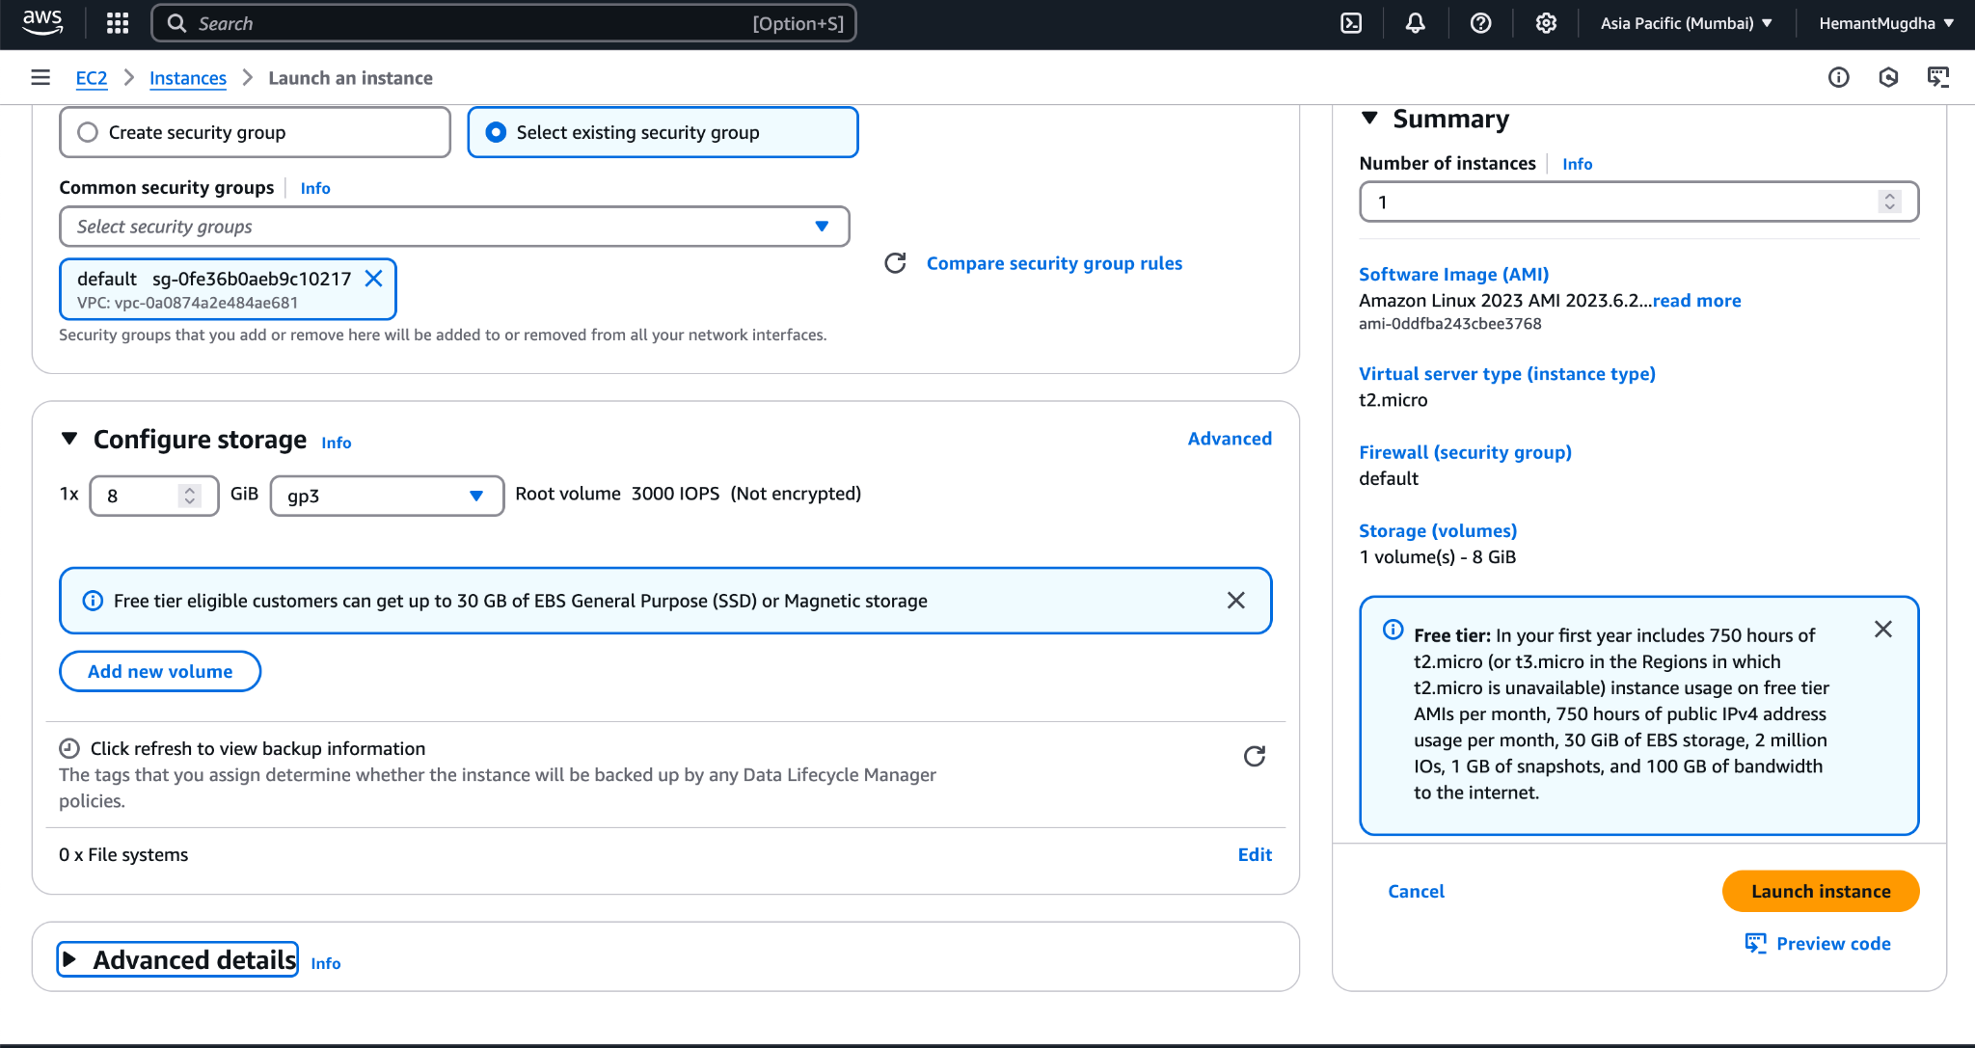
10. On **Successful creation** you will see following details.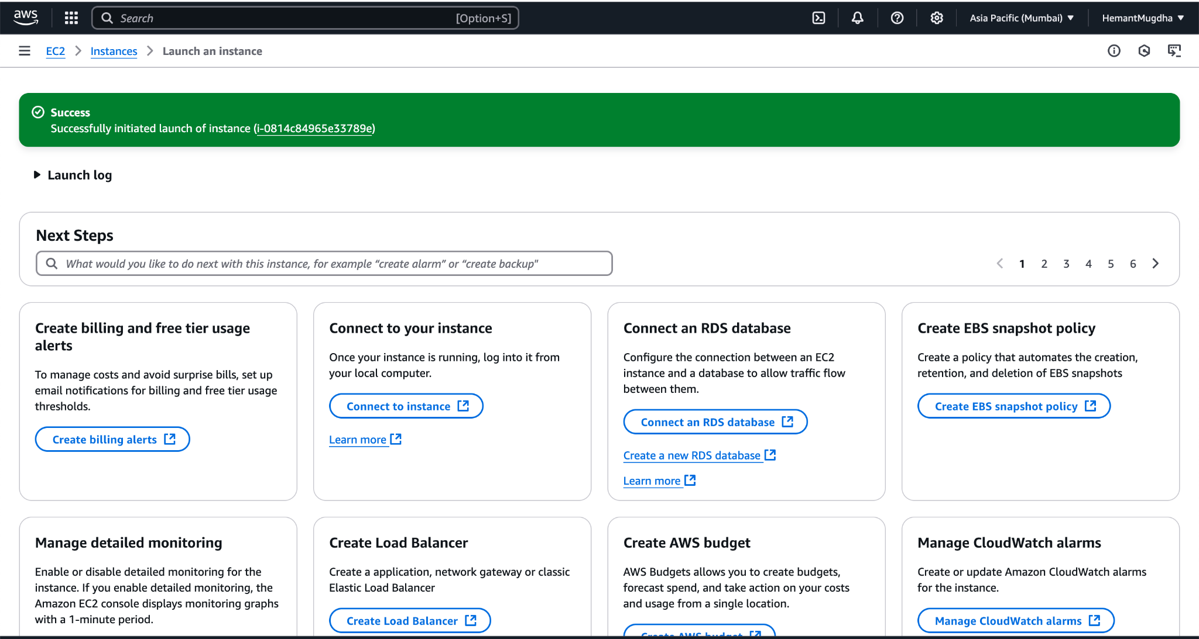

2. **HOW TO ADD ADDITIONAL STORAGE IN EC2 INSTANCE USING ELASTIC BLOCK STORAGE VOLUME**

1. Go to home page
2. Search for **EC2** >> Click of **EC2 under services**
3. When you land on EC2 Home page
4. Click on **Volumes** under **Elastic Block Store** on the left Pane. You will see the list of in use volumes as shown below >> Click on **Create Volume**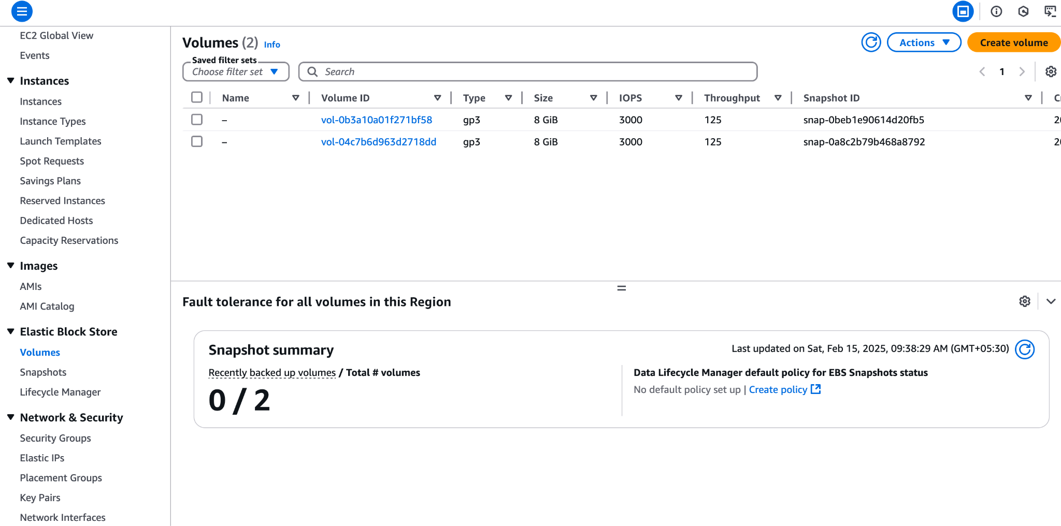
5. In **Create Volume** wizard. Provide the following details
   1. Select **General Purpose SSD(gp3)** in **Select Volume**
   2. Set **Size to 8 GiB**
   3. Make sure you select the same **Availability Zone** from ***Availability Zone dropdown*** as ***it is for the EC2 Instance.***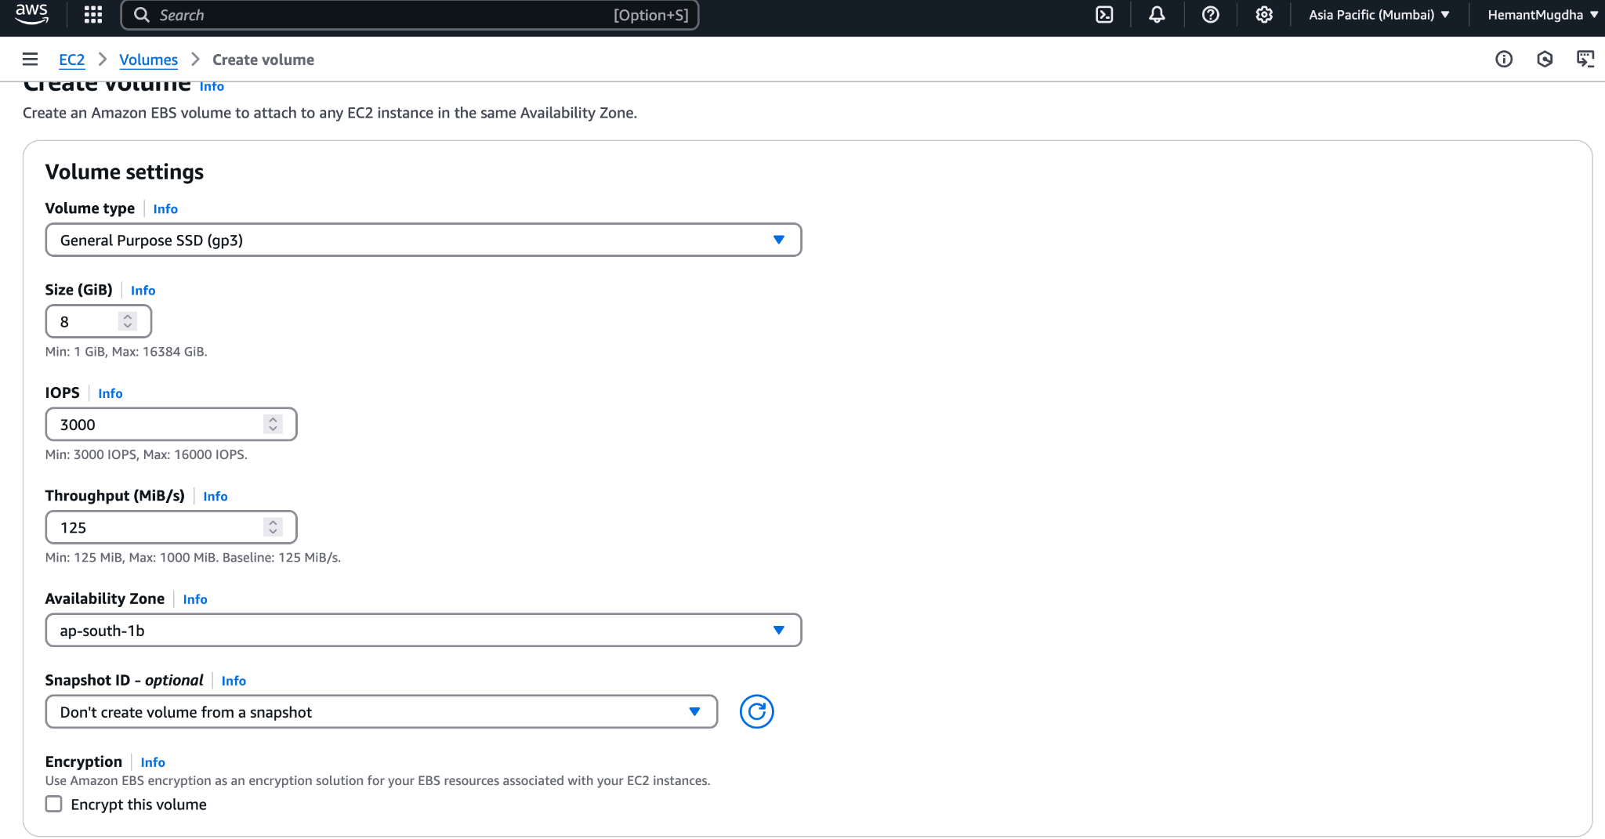
   4. Click on **Create Volume**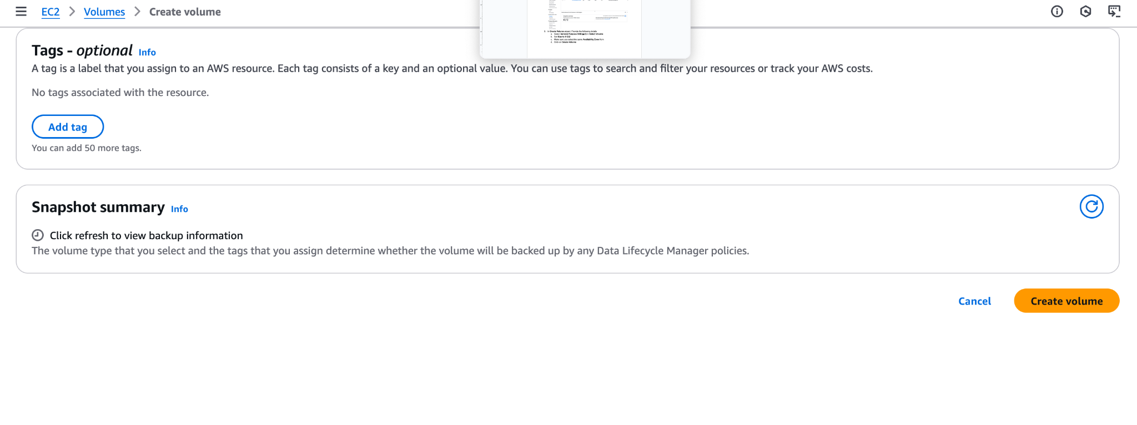
   5. To attach this volume to the instance >> **Select the Volume and click on name** >> **Volume Details** Screen shows up >> Click **Actions** button/dropdown on the right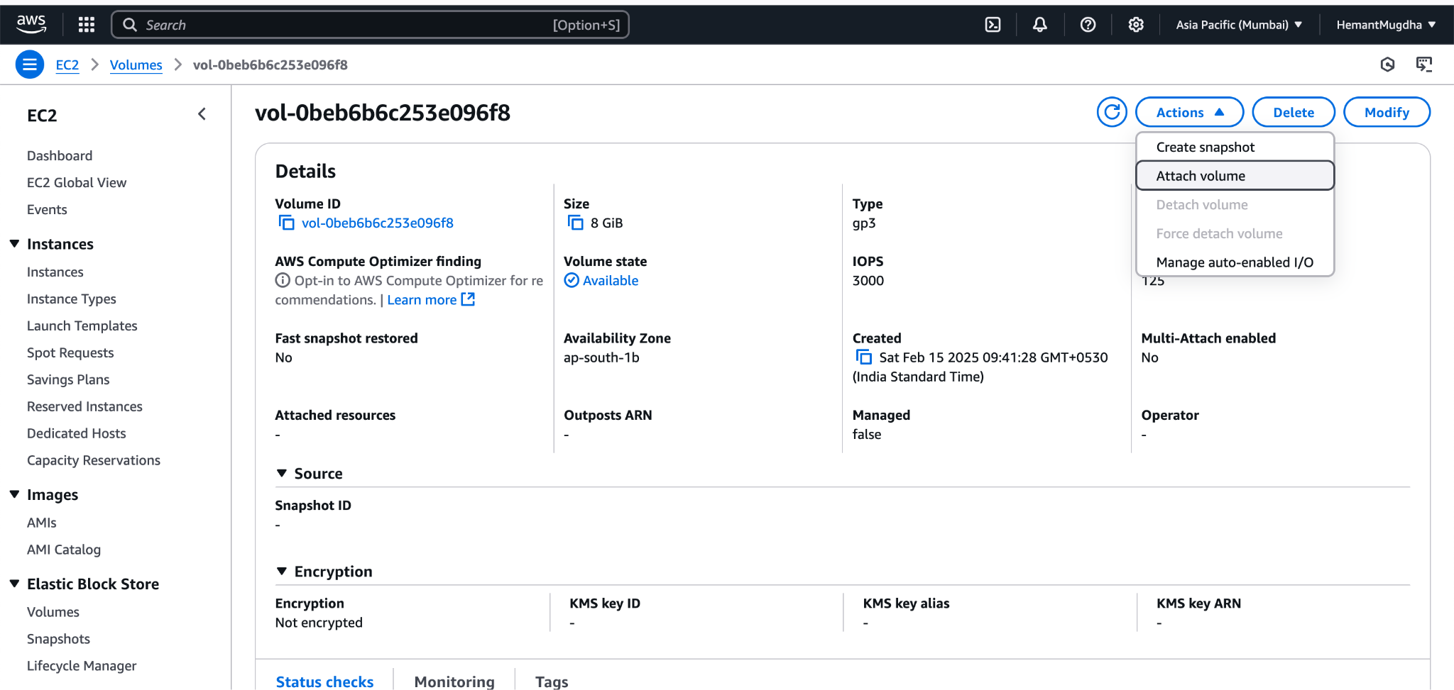
   6. In **Attach Volume** section >> Select the instance from **Instance** dropdown >> Click Attach Volume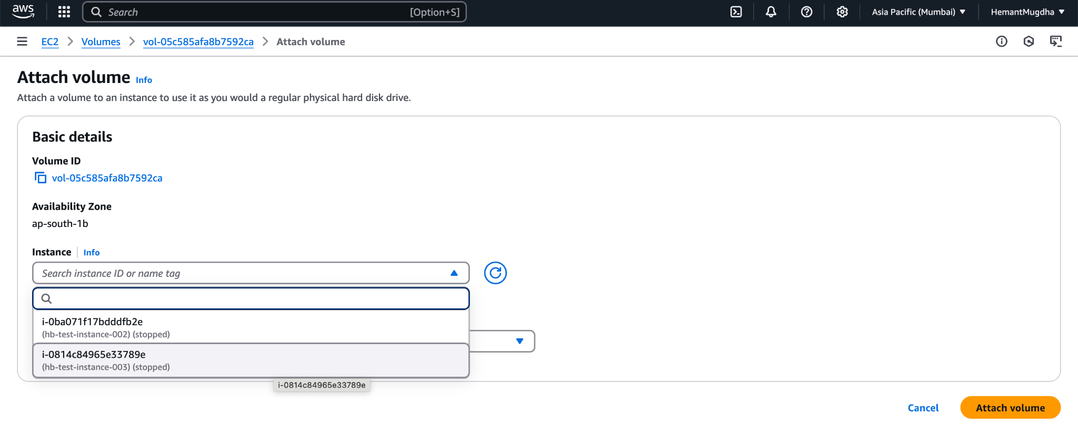
   7. On **successful** attachment, you can see the volume in the **Instance Summary >> Storage** section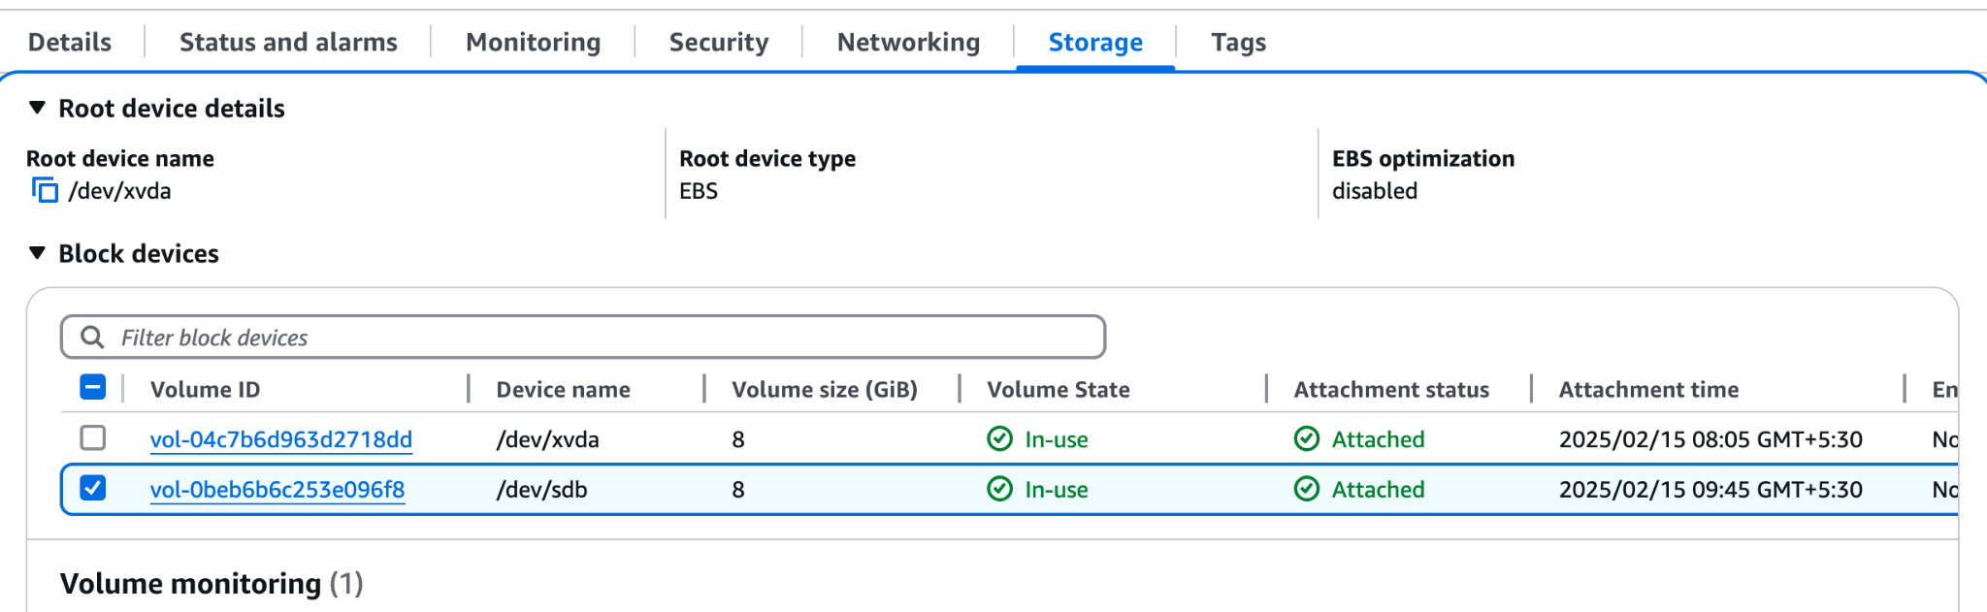

**3. RUN EC2 FROM COMMAND LINE**

1. Create an instance like in Section 1.
2. Make sure to attach a role with EC2 Full access
3. Connect to the new EC2 instance using the following command on mac ssh -i /Users/hemantbavle/Documents/AWSPersonalAccountDetails/hb2-ec2-keys.pem ec2-user@43.204.229.1
4. Before you do this, make sure you have changed the permission to PEM file using chmod command like the following, otherwise it might throw an error** - chmod 600 /Users/hemantbavle/Documents/AWSPersonalAccountDetails/hb2-ec2-keys.pem
5. Run the following command to switch to root user - sudo su
6. Run the following command to create an ec2 instance using the command line - [root@ip-172-31-12-170 ec2-user]# aws ec2 run-instances --image-id ami-05c179eced2eb9b5b --instance-type t2.micro --count 1 --key-name hb2-ec2-keys --security-group-ids sg-0e34af748ceea29aa
7. When running command in #6, do not add key type extension to the –key-name parameter, else it will throw error - An error occurred (InvalidKeyPair.NotFound) when calling the RunInstances operation: The key pair 'hb2-ec2-keys.pem' does not exist